Institute of Education Information and Prognoses
School Computer Center Banská Bystrica
Slovak Society of Electronics
Robotika.SK

SLOVAK NATIONAL CONTEST
in building and programming robots
for elementary and secondary schools
RoboCup 2008

ÚIPŠ-ŠVS Banská Bystrica

May 1.- 3. 2008

I N V I T A T I O N
13th annual national contest in building and programming robots for elementary and secondary schools

Contest goals: to promote interest in technology, develop creativity, and strenghten knowledge and skills of young people in the areas of building and programming automatic and cybernetic systems and controlling technological processes.

Contest Organizer: Slovak Society of Electronics
Robotika.SK
Contest Realization: Ústav informácií a prognóz školstva – Školské výpočtové stredisko Banská Bystrica
Organizing Committee: Ing. Miroslav Korman, Ing. Stanislava
Červeňová, Lukáš Boško, Miro Kohút
Contest Director: Mgr. Stanislav Slačka
Head of Jury: Mgr. Pavel Petrovič, PhD
Date of contest: May 1st – 3rd 2008
Place: Ústav informácií a prognóz školstva – Školské výpočtové stredisko Banská Bystrica
Tajovského 25, Banská Bystrica
Categories: Building
1. Robot building and programming using contestants' own sets on a given task
RoboCup Junior:
2. Robotic Football (Soccer)
3. RoboRescue
4. RoboDance

In the category Robot building and programming, both the pupils from elementary schools and students from secondary schools can take part, and the age categories will be ranked separately.

The participating groups of two students will build a model from their own robotics set (the brand and material is not restricted) and write a program so that the model will compelte the task specified by the Jury.

The scoring will be announced by the Jury before the start of the contest.
The Jury may take into consideration the differences between the construction sets when deciding on the score.

In all categories, the age of contestants is limited by 18 years (july 2008). Elementary and secondary schools will be ranked separately.
The rules will follow the international RoboCup Junior rules, the football matches will (most likely) be 2 x 5 minutes.

The winning Slovak teams in the RoboCup categories advance to the 12th World RoboCup Championship in Suzhou, China August July 14th – 20th . www.robocup.org

Registration:
To confirm the participation, please send mail to skse@skse.sk. with the following data:
Team name:
Names of contestants:
School name:
School address:
E-mail:
Mentor name:
Cell phone of mentor:

There is no registration fee. The teams are provided with accommodation and meals in the university dormitories (the price is 18 EUR per person for meals and accommodation), or they can stay in a hotel downtown, please let us know early about your accommodation preference. The teams from foreign countries will be heartily welcome!

Preliminary Schedule:

Thursday May 1st 2008
before 12:00 - arrival, on-site registration, accommodation
12:00 - lunch
13:00 - openning ceremony
14:00 - building and programming category
18:00 - dinner
19:00 - presentation of the models
after 19:30 - workshops

Friday May 2nd 2008 6:30 - waking up
7:00 - breakfast
8:00 - Robotic Soccer
13:00 - lunch
14:00 - Rescue and Dance
18:00 - dinner
20.00 - final ceremony

Saturday May 3rd 2008 6:30 - waking up
7:00 - breakfast
8:00 - departure

Orgnazational issues :

In order to allow future development of robotic and programming skills, the teams must agree to publish all facts about construction of their models including the software..

Each team will bring their own set to solve the specified task, or their own robot(s) for the RoboCup categories.
There is no limit on the number of teams per school. A team may compete in multiple categories.
There is a discussion forum For RoboCup Junior at robotika.sk and we encourage the participating teams to share their experiences in RoboWiki at
http://wiki.robotika.sk/index.php/RoboCup_Junior_Slovensko.
The organizing team reserves the option to update the schedule as needed, the participants will be informed in time. The local organizer will provide accommodation, meals, areals and computer equipment with Windows (you can bring your own notebook computers).
Any extra costs caused by inproper behavior will have to be compensated by those who caused it. The local organizer is not responsible for the equipment of the contestants.

Instructions for arriving by car:
From Vienna follow the highway A4 direction Budapest and then A6 direction Bratislava, where you switch to highway D2 direction Žilina/Nitra – the highway will lead you all the way through the city, you do not need to exit the highway at all. Follow about almost 100 km NorthEast, and exit in the direction Nitra. When you pass Nitra, you will keep in the direction Zvolen/Banská Bystrica, most of the journey is highway (shown red on the map), but there are some larger parts still missing in the middle. The map shows the recommended trajectory:

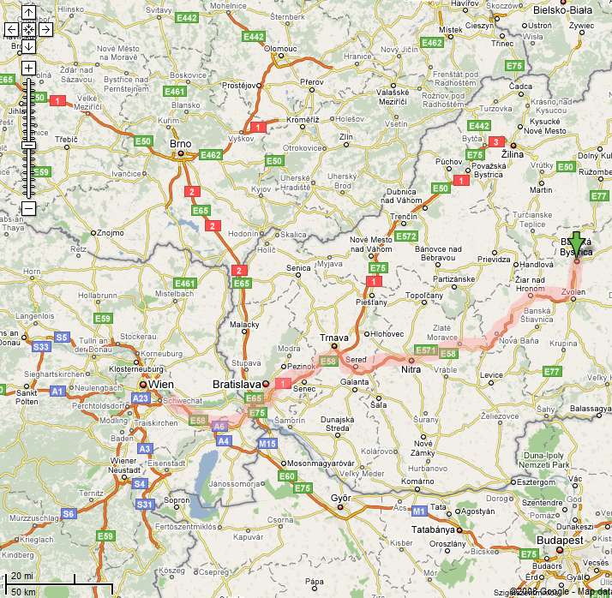
Inside of Banská Bystrica, you can follow the main road until a crossing in the direction of Tajov as shown on the more detailed maps:

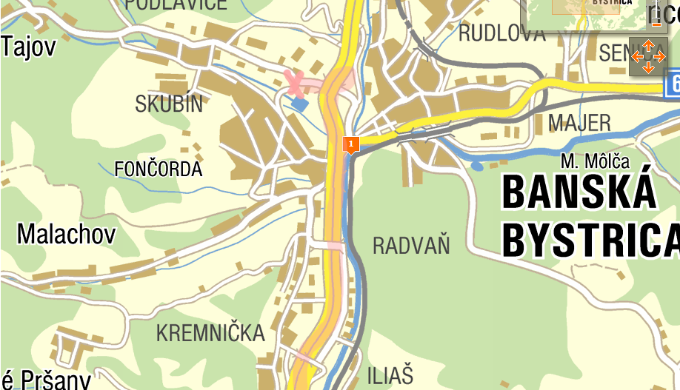

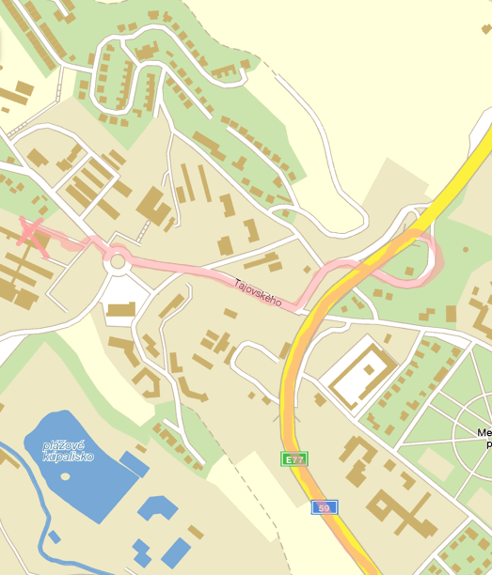
The driving time from Bratislava to Banská Bystrica is about 2-3 hours.
For more details, you can contact Pavel at +421-915772685
e-mail: ppetrovic@acm.org.

